**Software Proposal**

**ClinicTrends AI Project**

**Group:** 1

**Students:**

Luis Guilherme de Barros Andrade Faria - **A00187785**

Jing Feng Chin - **A00178098**

Luong Hai Chau - **A00117495**

**Subject Code**: SEP 401

**Subject Name**: Software Engineering Principles

**Assessment No.**: 1

**Title of Assessment**: Proposal

**Lecturer**: Dr. Ranju Mandal

**Date**: June 2025



# **Introduction**

In the competitive landscape of aesthetic clinics, customer satisfaction is crucial for business sustainability. However, satisfaction is often measured reactively using Net Promoter Score (NPS) surveys, providing delayed insights. Most clinics lack tools for proactively analyzing and predicting trends in customer feedback.

# **Similar Work**

Industry leaders such as **Medallia** and **Qualtrics** provide comprehensive experience management solutions that include survey distribution, data aggregation, and trend analysis. However, these platforms typically come with significant subscription costs and are primarily designed for large organizations, making them inaccessible for small to medium-sized business, such as small and medium sized businesses. Alternatively, tools like **SurveyMonkey** enable businesses to collect feedback and display results through static dashboards and email summaries. While useful for capturing customer sentiment, such tools lack predictive capabilities and offer limited insight into the drivers behind satisfaction scores.

Academic literature also supports the need for more actionable insights in this domain. For example, Ahmad et al. (2013) identify key software maintainability and satisfaction indicators, which can inform the feature selection process for machine learning models aimed at forecasting customer behaviour.

# **Proposed Solution**

**ClinicTrendsAI** is a Python-based software solution powered by machine learning that enables proactive customer satisfaction management. Built using **Streamlit**, the application will load survey data from CSV files and produce visual analytics, predictive forecasts, and feature analysis to guide managerial decisions. The core features of the application include:

* Historical visualizations of NPS over time, by clinic location or staff group;
* Machine learning predictions for future NPS;
* Alerts for negative trend thresholds;
* Feature impact analysis to understand drivers of satisfaction.

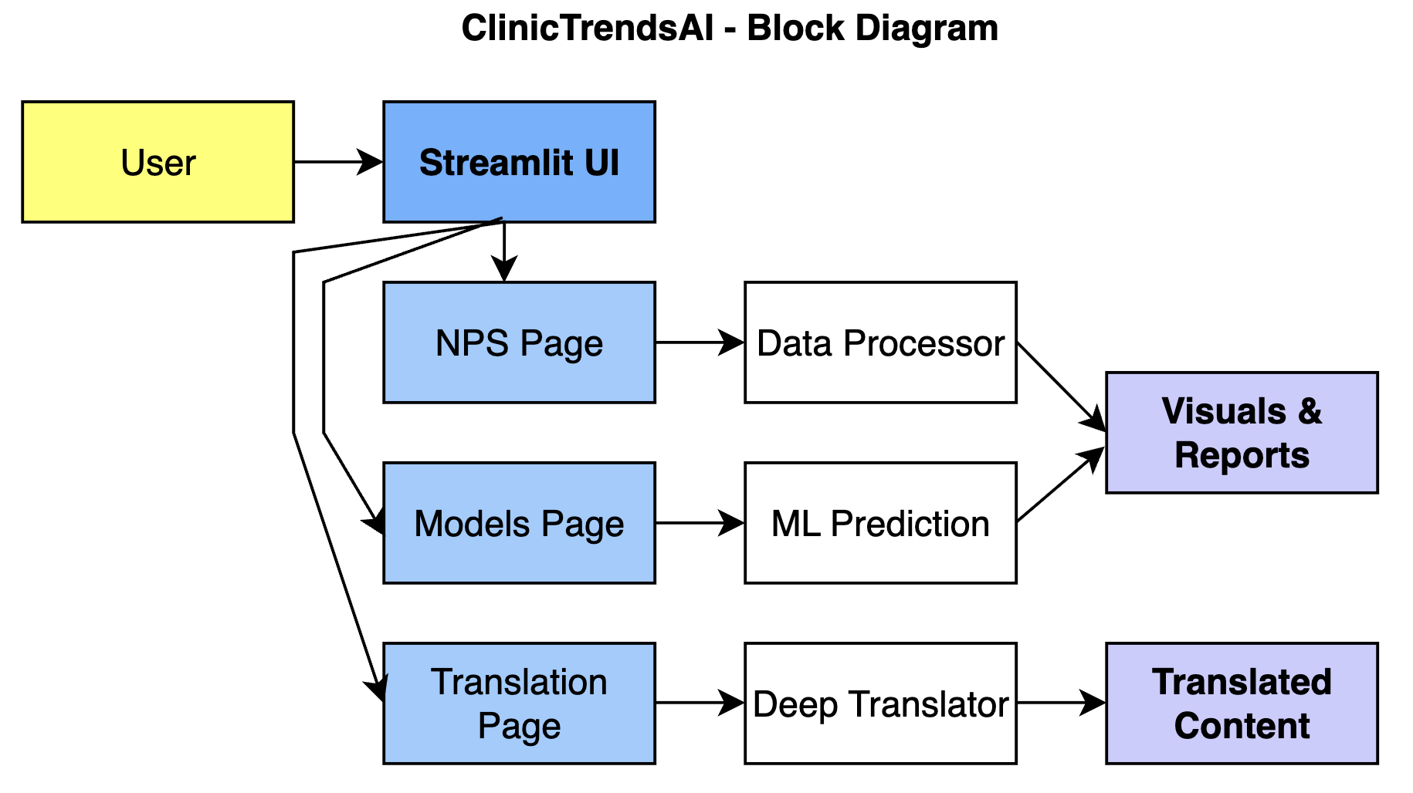

***Figure 1:*** *illustrates the proposed system architecture for ClinicTrendsAI.*

# **Business Values**

**Clinic Trends AI** provides significant value to small and medium-sized businesses by:

* **Cost-Effectiveness**: Offering an open-source solution, reducing reliance on expensive subscription-based platforms.
* **Proactive Decision-Making**: Enabling managers to anticipate and address satisfaction issues before they escalate, reducing churn.
* **Scalability**: Supporting clinics of varying sizes with a lightweight, cloud-compatible application.
* **Operational Efficiency**: Automating data analysis and providing clear, actionable insights, saving time and resources.

**Monetization Plan:**

ClinicTrendsAI will use a freemium model. Basic visualizations are free, while premium features like ML predictions and PDF reports will require a subscription, starting at AUD $49/month.

# **Project Plan**

The proposed project will be implemented over 12 weeks using a Scrum-based Agile methodology (Heath, F. 2021). The development is divided into **six sprints**, each lasting two weeks. This approach supports iterative improvement, rapid feedback incorporation, and adaptability to evolving requirements from stakeholders and data insights.

Key activities include:

* Data cleaning and feature engineering.
* Developing ML models.
* Designing UI components.
* Testing and deployment.

And the final deliverables:

* Interactive dashboard MVP.
* Machine learning module.
* Alert system.
* User documentation and demo video.

## **Risk Assessment**

Every software project faces risks that may affect timeline, quality, or scope. For ClinicTrendsAI, key risks include:

* **Data quality issues:** Incomplete or messy CSV files could disrupt analysis. Mitigation: Implement validation, provide user templates.
* **Model performance issues:** Underfitting or overfitting could affect predictions. Mitigation: Apply cross-validation and testing.
* **Stakeholder availability:** Limited feedback could delay refinements. Mitigation: Schedule early demos and async feedback.
* **Scope creep:** New feature requests may expand scope. Mitigation: Maintain a clear backlog and enforce boundaries.

These risks will be actively monitored throughout the project.

## **Gantt Chart**

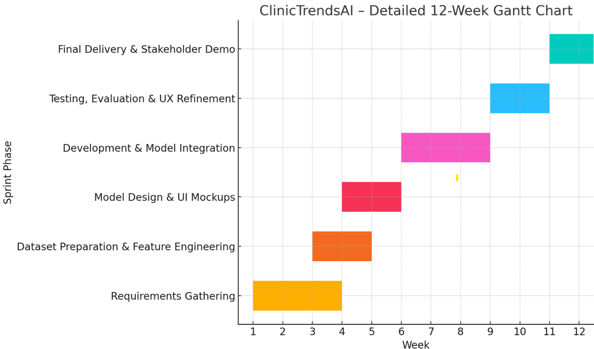

***Figure 2:*** *Project phases outlined for the 12-week plan.*

# **References**

* Ahmad, M. O., Markkula, J., Oivo, M. (2013). Factors affecting software maintainability from customer perspective. Journal of Systems and Software.
* Cobb, C. G. (2015). The Project Manager's Guide to Mastering Agile. Wiley.
* Ewusi-Mensah, K. (2003). Software Development Failures. MIT Press.
* Heath, F. (2021). The Professional Scrum Master Guide. Packt Publishing.
* Medallia. (n.d.). The #1 Experience Management Platform. Retrieved June 16, 2025, from https://www.medallia.com/platform
* Qualtrics. (n.d.). Qualtrics by use case. Qualtrics. Retrieved June 16, 2025, from https://www.qualtrics.com/use-case/
* SurveyMonkey. (n.d.). SurveyMonkey: The world’s most popular survey platform. https://www.surveymonkey.com
* Stephens, R. (2015). Beginning Software Engineering. Wrox Press.